EXPERIMENT 8

Consider Sales Data set. Integrate R environment to power BI platform and perform the following
- Create Smart Narrative, Create Q&A Visuals and Create decomposition tree
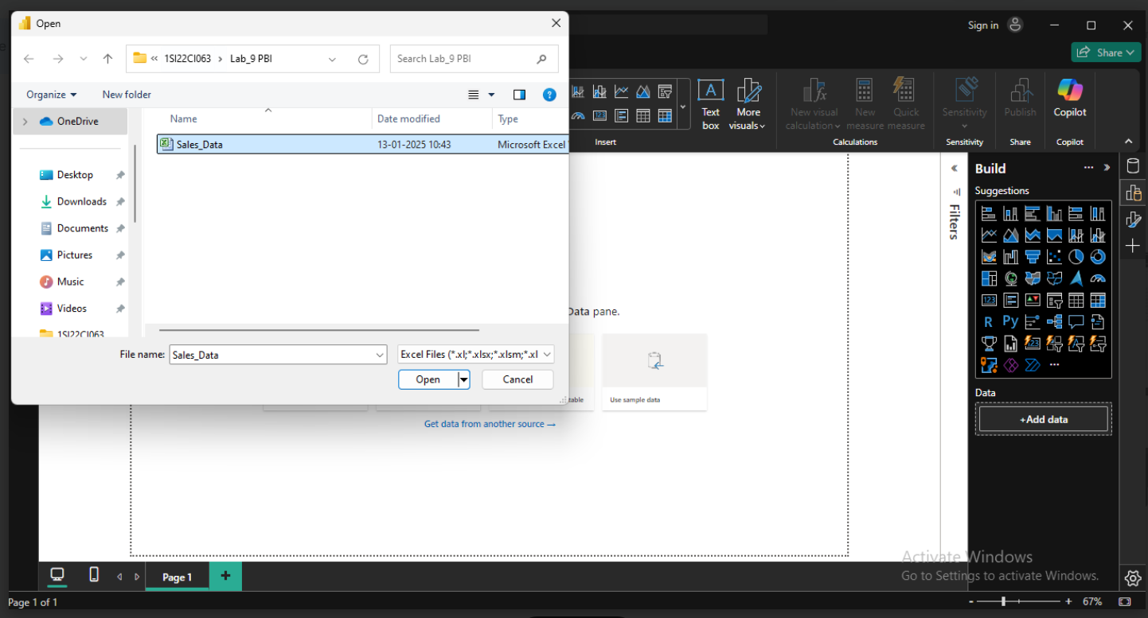

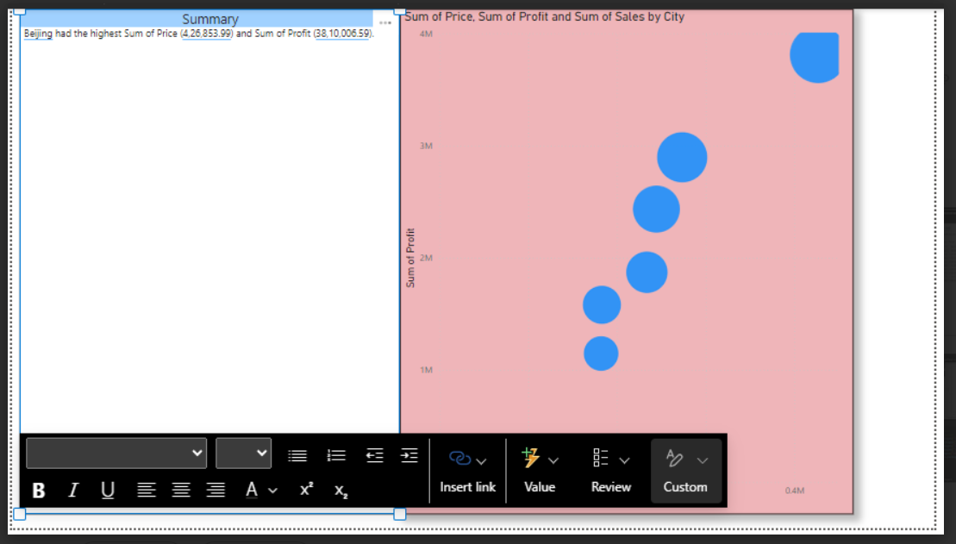

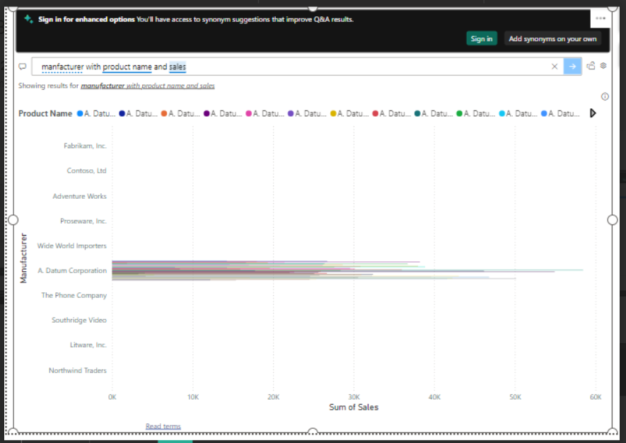

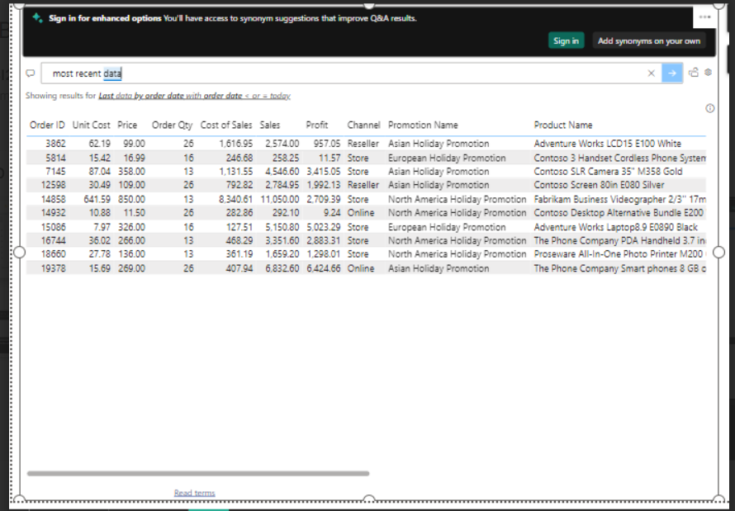
- Using R packages, Build ML based classification Model and Build ML based Data Model, and Build ML based Clustering Model
